Q-1 Which of the following is not a valid variable type ?
A-1 item

Q-2 Which one of the below is not a valid data type in terraform ?
1. set 2. array 3. list 4. map 5. tuple ?
A-3 array – array is the list.
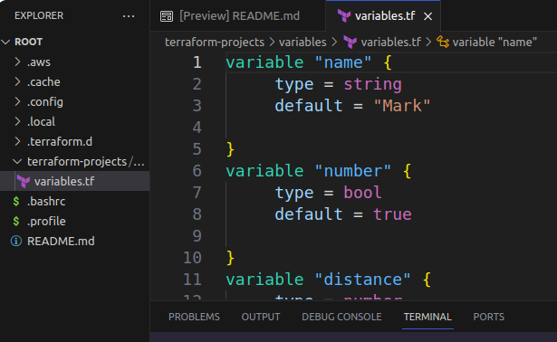
Q-3 Navigate to the directory /root/terraform-projects/variables. Which type does the variable called number belong to?
1. list 2. string 3. bool 4. number ?
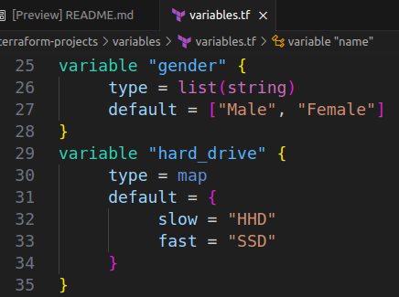
A-3 bool q-Q-4 How would you fetch the value of the key called slow from the variable called hard_drive in a terraform configuration?
This variable is defined in the file variables.tf.
1. var.hard_drive[“slow”] -- Right.
2. hard_dirve[“slow”]
3. var.hard_drive[0]
4. var.har_drive.slow ?

Q-5 What is the index of the element called Female in the variable called gender ?
A-5 Index of Female element is “ 1 ”.
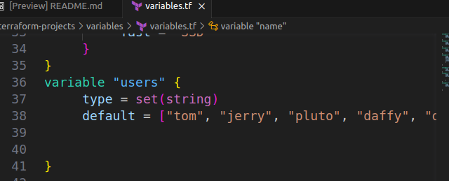
Q-6 What is the type of variable called users ?
A-6 set(string)
Q- 7 However, this variable has been defined incorrectly! Identify the mistake.

A-7 In set(string) , the elemetn named jerry is repeating 2 times.

For set variable – it should unique, not repeating, duplicate.

